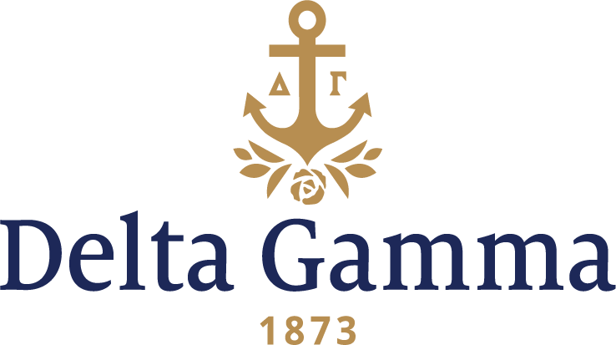

**Beta Lambda-Gettysburg**

**Fast Facts:**

* Installation date: October 7, 1939
* Location: Gettysburg, Pennsylvania
* Region: 1

**History:**

Gettysburg College was founded in 1832, as a sister institution for the Lutheran Theological Seminary. Both owe their inception to Thaddeus Stevens, a Radical Republican and abolitionist from Gettysburg. The college's original name was Pennsylvania College, and was founded by Samuel Simon Schmucker. In 1839, seven years after Gettysburg College was first founded, Drs. George McClellan (founder of Jefferson Medical College), Samuel George Morton, and others, founded a medical school, Pennsylvania Medical College, located in Philadelphia. The school had money troubles within four years, forcing all founding members to leave their posts. After a failed agreement to combine with the Philadelphia College of Medicine in 1858 (closed in 1859, with the faculty begin rolled into Pennsylvania Medical College), the college was forced to close the medical school in 1861. Students from the seceding southern states had withdrawn to return home, leaving it without adequate revenue. In 1888, women were admitted to Gettysburg College.

In 1916, Beta Lambda local sorority founded on “six great rights”: recognition of girls rightfully belonging at Gettysburg College; right of girls to enjoy the privileges on the campus, denied to them but granted to male students; right to be recognized as an organized campus group; right to have properly supervised living accommodations for out of town girls and a place for meeting purposes; right to belong to a national sorority group; right to have proper representation of women on the faculty, on the Board of Trustees and on the alumni bodies.

In 1923, Beta Lambda first approached Delta Gamma. Although, from 1932-1935, Gettysburg College discontinued their co-education curriculum. In 1936, women were allowed back in Gettysburg College, and Beta Lambda returned.

In 1938, Else Singmaster Lewars, Chi-Cornell, helped to petition the Fraternity and establish the Beta Lambda chapter of Delta Gamma. Finally on Saturday, October 7, 1939, Beta Lambda installed as a Delta Gamma chapter at the Gettysburg Hotel. That afternoon, a total of 62 pledges were initiated: 32 collegians, 27 alumnae, and 4 patronesses. After initiation there was a banquet which included highlighted by the presentation of the charter by Marguerite Winant, Fraternity President, to Marion Sheely, chapter president. A model chapter meeting was held Sunday morning when the officers were installed by Ms. Sheely. On Sunday afternoon, approximately 300 guests attended a reception to introduce the newly installed chapter to the campus and town.

In the 1940s, Beta Lambda was number one scholastically for the entire word, except for one year. In 1943, the chapter moved into Phi Sigma Kappa house across the street from Huber Hall. Mrs. William Boyson was first housemother. In 1948, Beta Lambda entertained at the 33rd Convention in Swampscott, Massachusetts, and coordinated rush skits to be presented by host chapters in Provinces I & II.

In 1951, the Beta Lambda chapter moved into Hanson Hall. In 1954, there was a complete redecoration of the room, including new rugs, drapes and furniture. Fraternity President, Mrs. Robert Preston visited the Beta Lambdas in 1956. Throughout the 1950s and 1960s, Service for Sight & Aid to the Blind was an integral part of chapter’s busy schedule. Originally fashion shows were held as fundraisers. However, selling Christmas cards, hand painting neckties with the fraternity crest, and selling Avon products were used to raise funds for the Foundation. Each of the ideas were profitable, and in 1951-1952, the chapter received first place for the most contributions to the Foundation. In the ‘60s, the chapter sponsored foreign students from Denmark, Germany and The Netherlands.

Beta Lambda held their first Anchor Splash® in 1975, and became their major fundraiser. However, the ‘70s were also marked with troublesome times as there was a great deal of hostility surrounding Greek Life at Gettysburg. Despite this, Beta Lambdas reputation was not marred. In late 1970, Beta Lambda worked to promote good relations with faculty and administration by holding an annual faculty picnic and semi-annual faculty teas.

Beta Lambda helped install the Epsilon Lambda- Lehigh chapter of Delta Gamma in 1978. In the 1980s, the chapter started reading to a blind student. In 1981, they initiated the “Battlefield Tour for the Blind.” Beta Lambda again helped install Epsilon Beta-Bucknell chapter of Delta Gamma in 1982.

Beta Lambda has several campus traditions that they hold near to their hearts. Every year the most outstanding pledge in scholastics has their name engraved on a trophy cup. The most outstanding senior’s name is engraved on a representative plaque that was named for a Delta Gamma who died during her second year at Gettysburg. The Sunday after pledging and Initiation is observed by the entire chapter attending church together. The first home football game after pledging, Delta Gamma pledges wear huge yellow chrysanthemums with pink and blue ribbons to the game. A formal dance honors the seniors every February. Every Founder’s Day in March is when new officers are introduced.