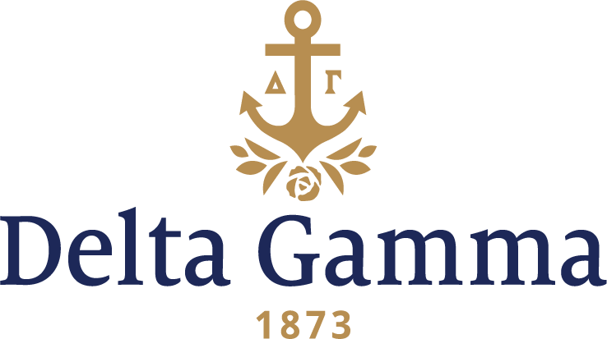

**Beta Nu-Carnegie Mellon**

**Fast Facts:**

* Installation date: January 29, 1944
* Location: Pittsburgh, PA
* Region: 1

**History:**

Carnegie Mellon University is a private research university in Pittsburgh, Pennsylvania. Founded in 1900 by Andrew Carnegie as the Carnegie Technical Schools, the university became the Carnegie Institute of Technology in 1912 and began granting four-year degrees. In 1967, the Carnegie Institute of Technology merged with the Mellon Institute of Industrial Research to form Carnegie Mellon University.

The Fraternity was first contacted by women at Carnegie Melon in October 1914. Women of Alpha Sigma Pi, a local group formed in 1912, were interested in affiliating with a national organization. Unfortunately, they were notified by the Fraternity in 1915 that the expansion committee was not interested in expanding to Carnegie Melon.

In 1943, Kappa Kappa Gamma passed along the information about as a local group that was interested in affiliating with a national organization. This local sorority, Gamma Phi Sigma, had hoped to affiliate with Kappa Kappa Gamma, but was duly excited to affiliate with Delta Gamma instead. By October 1943, preparations were nearly complete for the Installation of the Beta Nu chapter.

Beta Nu was the only Delta Gamma chapter installed in 1944 as the nation was in the midst of World War II.

Council met while in Pittsburgh to attend the Installation of Beta Nu chapter. It was at this Council meeting that the field secretary program, now known as the Collegiate Development Consultants (CDCs) had its beginning. Provision was made for Jean Pierce from Central Office to visit a chapter to help with chapter problems.

During these days WACs and WAVEs and members of all of the other US and Canadian branches of service for women were featured in the *ANCHORA*. Beta Nu members led the campus in the purchase of war bonds, held a war stamp campaign to purchase a field ambulance to be sent overseas, and over 50 percent of the chapter donated blood to the Pittsburgh Blood Bank.

Members of Council, the *ANCHORA* Editor, the Executive Secretary, and the ten province secretaries attended a training school (in place of Convention) in Columbus on the D-Day invasion of France on June 6, 1944.

The chapter has continuously shown their support for philanthropy and service through constant fundraisers and participation in campus-wide events such as Greek Sing and Booth. The chapter’s enthusiasm for these events shows their desire to challenge themselves to deliver good performances and projects while raising as much money for the cause as possible. Beta Nu women enjoy volunteering at The Western PA School for the Blind, Shadyside Nursing Home, and Annual Vision Walks and many other organizations to support our philanthropy.

The Beta Nu house is in the Greek Quad off of Forbes Avenue, across from The University Center. Before moving to the Greek Quad, they were housed on Morewood Avenue, where many sororities and fraternities still reside.