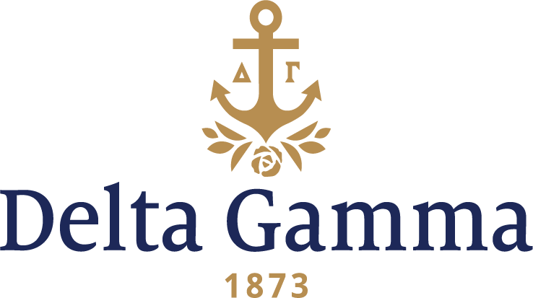

**Beta Upsilon-Oregon State**

**Fast Facts:**

* Installation date: April 27, 1946
* Location: Corvallis, OR
* Region: 7

**History:**

The university's roots date back to 1856, when it was established as the area's first community school for primary and preparatory education. Throughout the university's history, the name changed eleven times. Like other early established land-grant colleges and universities, the majority of name changes occurred through the 1920s. Generally, name changes were made to better align a school with the largest available federal grants in agriculture research.

Corvallis area Freemasons played an important role in developing the early school and several large campus buildings are named after these founding fathers. The school offered its first college-level curriculum in 1865, under the administration of the Methodist Episcopal Church, South.

On August 22, 1868, official articles of incorporation were filed for Corvallis College. October 27, 1868, is known as OSU Charter Day. The Oregon Legislative Assembly designated Corvallis College as the "agricultural college of the state of Oregon" and the recipient of the Land Grant. Acceptance of this grant required the college to comply with the requirements set forth in the First Morrill Act and the name of the school was changed to Corvallis State Agricultural College. The school was then authorized to grant the Bachelor of Arts, Bachelor of Science and Master of Arts degrees. The first graduating class was in 1870, granting Bachelor of Arts degrees.

A growing diversity in degree programs led to another name change in 1937, when the college became Oregon State College. The university's current title, Oregon State University, was adopted on March 6, 1961, by a legislative act signed into law by Governor Mark Hatfield.

Delta Gamma first considered expansion to the college in 1926.

In 1945, the Portland alumnae and the members of Alpha Delta-Oregon were enthusiastic about establishing a chapter at Oregon State. On September 28, 1945, all girls who had registered for rush at Oregon State College found the following announcement with their second date cards:

*A petition from Delta Gamma, national fraternity for college women, to start an Oregon State College chapter was acted upon favorably by the Student Affairs Committee of the college at one o'clock today.* *Delta Gamma will therefore start a program of rushing and pledging immediately at the close of this rush period.*

Province Secretary Ruth Herman, Fraternity President Florence Bingham, Kate Sexton Booth, Beta- Washington, and Helen Loughary, alumnae chairman of Portland, selected 12 collegians and two patronesses (Mollie Strand and Louise Kierzek) as the nucleus of the colony. In November, Mollie Strand and Louise Pierce Kierzek were initiated with the members of the new Beta Pi-Willamette. They became the first members of Beta Upsilon chapter.

Early in December 1945 the colony moved into a former fraternity house. The next two weeks offered a test of their devotion and endurance. The roof of the sleeping porch leaked on their beds, the sawdust burner consumed loads of fuel but produced little heat, and winter storms made the walks to classes and meals uncomfortable. During vacation, a new roof was put on, the furnace repaired, the kitchen was painted, a cook was hired, and a generous gift of furniture (over $850 worth) from the Portland alumnae association renewed the energy and enthusiasm of the group.

The girls welcomed the arrival of Jean Pierce, Field Secretary, to act as advisor and house chaperone. Additional pledges were added to bring the number of new colony members to 23. They called her "Mama Superior" and guiding light of Beta Upsilon.

Installation and Initiation was held on April 27, 1946 at the Phi Delta Theta house with Jean Pierce, Field Secretary, Ruth Herman, Province Secretary, and members of Alpha Delta-Oregon conducting the ceremony. A formal banquet was held at the Benton Hotel with the theme "Symphony." The place cards were in the shape of musical instruments and the programs had the first bars of Beethoven's Fifth Symphony in bronze on white and announced the premier performance of Beta Upsilon. A reception for 300, with music from a string orchestra, was held at the Memorial Union Building the following day. Delta Gamma National Fraternity President Florence Bingham, Chi-Cornell recognized the charter organization as the 63rd collegiate chapter.

Many traditions were established after installation, and others began throughout the 1950s and 1960s. Self-paced study tables with ice-cream study breaks became tradition. They also recognized scholars every Monday night with an award called “The Plant of Knowledge;” it was given to the most studious person of the week, who would then take care of a beautiful plant for a week. Good grades were also rewarded with a scholarship dinner – all 3.5 GPA and above ate steak for dinner, while others dined on hamburgers. Other ways they have recognized members who have contributed to the chapter was acknowledging them on Monday nights by reading “Orchids and Onions,” the passing of “Happy Hannah,” the outstanding pledge received a “you are special” red plate to eat off of, and an exceptional senior received a white rose. DG Dad’s weekend had a “game” night with black-jack tables, pool, foosball, and ping-pong. The winner of the most games received a ribbon inscribed “Things go Better with Dads.” Dance contests were held featuring the bump or hustle and included 50’s style rock-n-roll. Mom’s weekends were usually held during IFC Sing competition. The house also loved “firesides” to talk about concerns and hopes. They held candle passings to congratulate the accomplishment of a sister. Pledges held “walkouts,” a tradition where pledges mess up the house and go somewhere together for a weekend, then return on Sunday for a pledge brunch. However, at Monday night dinner the members would show their appreciation for the prank by making the pledges eat bread and water for dinner. The winter term house dance theme used to be old Las Vegas with derbies and garters for favors, which became a very popular event on campus. They held open houses for tick-or-treaters on Halloween. Seniors held a “Bon Voyage Bash”, their last house dance, often including a trip for a couple someplace. They raised funds for this and their senior gift by holding an annual Godfather date dinner, Italian style, for the other Greeks. Later it became an “Aloha” party.

Philanthropy and the Foundation were very important to the chapter. Early on, service traditions included assisting a retired professor who was blind and helping a family with two parents who were with grocery shopping and tutoring the children as needed. Every fall they volunteered at Garfield Elementary for sight screening and collected old glasses on campus for Lions Club.

The first Anchor Splash® was held in 1980. Seven hundred dollars was raised to sponsor a week of vision screening. These activities continue today.

A 1994 graduate and DG, Margo Evashevski, was named outstanding student-athlete in the U.S. as Academic All-American of the Year by the NCAA.

The present Beta Upsilon chapter house was dedicated on November 15, 1969. Two lounges in the house were dedicated to Mary Sargent Neville, Beta Pi-Willamette and Louise Pierce Kierzek, Beta Upsilon because of their continued devotion and service to the Fraternity and Beta Upsilon.