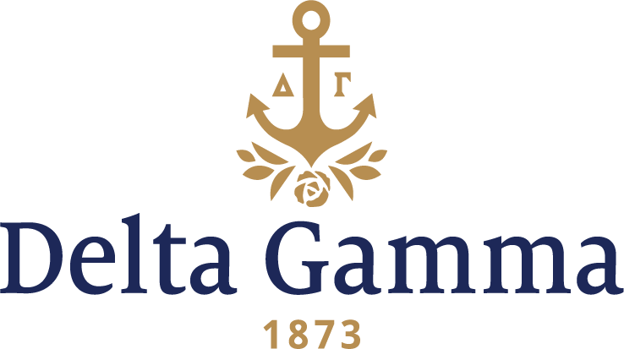

**Epsilon Alpha-Union**

**Fast Facts:**

* Installation date: April 8, 1978
* Closure date: May 21, 2000
* Location: Schenectady, New York
* Region: 1

**History:**

Union College became the first college chartered by the Board of Regents of the State of New York in 1795. The name Union reflected the founders' desire to create a welcoming, unified academic community open to all the diverse religious and national groups in the region. Today, Union remains one of the oldest non-denominational colleges in the country with a rich history that blends respect for tradition with an emphasis on continuous innovation.

Delta Gamma’s interest in Union College began when a local sorority petitioned the Fraternity for a charter. Council granted their charter, and the Epsilon Alpha chapter was established on Union’s campus on November 6, 1977. Women of Chi-Cornell conducted the pledging ceremony. Epsilon Alpha joined the only other NPC organization on Union’s campus, Sigma Delta Tau.

The Epsilon Alpha chapter was formally installed on April 8, 1978. Women of the Rho-Syracuse chapter conducted the Initiation ceremony. Following Initiation, a formal Initiation banquet was held at the Mohawk Golf Club. A formal reception for the new chapter was held on Sunday, as well as a formal chapter meeting that evening.

The Epsilon Alpha chapter did not hesitate once formally installed. Beginning in April of 1979, the chapter held a campus-wide fundraising event called Delta gamma Olympics. The chapter held this event annually for at least 13 years. In the mid 1980’s, the Epsilon Alpha’s had the highest GPA of the NPC organizations on campus and were the second largest chapter on campus.

The chapter was closed by the Fraternity on May 21, 2000.