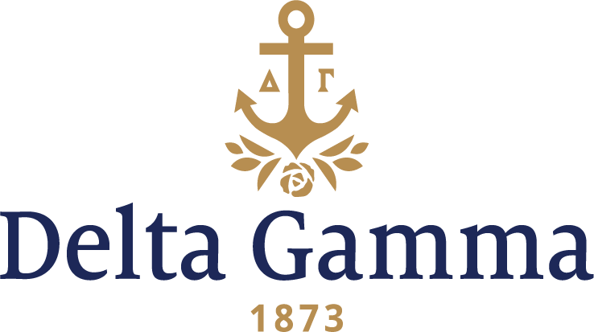

**Eta Tau-Christopher Newport**

**Fast Facts:**

* Installation date: November 15, 2014
* Location: Newport News, Virginia
* Region: 2

**History:**

In 1960 the city of Newport News joined together with the Commonwealth of Virginia to create Christopher Newport College, which opened its doors in 1961. At the time, it was located in the old John W. Daniel School building. The college was founded as an extension of the College of William & Mary and offered extension courses that had been unavailable in the area for some time. The college was named after Christopher Newport, who was the captain of the largest of three ships that carried settlers in 1607 on the way to find the settlement at Jamestown in the Virginia Colony- the first permanent English settlement in North America. In 1964 the college was relocated to its current location, a 75-acre tract of land purchased and donated by the city. In this same year, the college's first permanent building was dedicated as Christopher Newport Hall. In 1971, CNC became a four-year college; however, it remained an extension of William & Mary until 1977 when it attained its independence. In 1992, the college became a university under the leadership of President Anthony R. Santoro, who oversaw the building of the first residence hall. In 1996 CNU made plans to become more competitive. Those plans included the expansion of University property, several new buildings and residence halls, as well as overhauling academic programs and the admission process. In 2013 it was ranked number 7 among top public regional universities in the South, and number 18 on the overall regional university list for the South.

In November 2013 Delta Gamma Extension Team visited the campus to ensure the campus was prepared to add another sorority. The following January 2014 Council Appointed Coordinator Becky King and RCRS 2 Maddie Brown observed formal recruitment, then in February they manned a table in the CNU Winter Club fair and answered questions from interested students. In early April meetings were scheduled to prepare for the colonization and spread the word the DG was coming to the university. There are nine National Inter-fraternity Council fraternities on campus and Delta Gamma Fraternity became the eighth National Panhellenic Conference sorority to colonize on Sunday, September 7, 2014. To be known as Eta Tau chapter of Delta Gamma, the colony joined Alpha Phi, Alpha Sigma Alpha, Gamma Phi Beta, Phi Mu, Zeta Tau Alpha and Alpha Delta Pi.

Colonization Team members were Staci Skoog, Fraternity President; Tracey Williams, Interim Executive Director; Cheri Wechsler, Director of Expansion, Lorie Hunter, Director of Expansion and Consultants; Hannah Krydynski, Extension and Colony Specialist; Christine Rocchio, Region 2 Director; and Becky King, Eta Tau Council Appointed Coordinator. Collegiate Development Consultants who assisted were Kate Clark and Julia Berk, Colony Consultants; Keilah Johnson and Marie Eickhoff.

The Colonization week began on September 3 with Colony interviews for three days, membership selection and a Preference event performed by 35 women of Epsilon Gamma-Virginia on September 6. The chapter members performed the beautiful Lei Ceremony for a total of four parties. Thirty-one women attended each event which included a welcome speech by Fraternity President, Staci Skoog, as well as Epsilon Gamma chapter president and a senior member of their chapter. On September 7, Bid Day began with a community-wide celebration in the afternoon of the Panhellenic community on the Library Plaza as 114 Delta Gamma new recruits received their bid cards. Each colony member emerged from the Student Union and was greeted with hugs from the colony consultants and a huge roar of excitement from the crowd. The celebration moved to the Music and Theater Hall where colony members were presented with a bid day bag, including a t-shirt which they changed into for their official photo that included the University and Fraternity Presidents. A reception followed where congratulatory speeches by CNU Administrators and the Dean of Students (whose wife is a Delta Gamma) were given and members of the Virginia Tidewater Alumnae Chapter brought gifts for each new chapter member.

On Saturday, November 15, 2014, Eta Tau Chapter of Delta Gamma Fraternity officially became the fraternity’s 194th chapter to receive a Charter and the 146th active collegiate chapter on campuses across the United States and Canada.