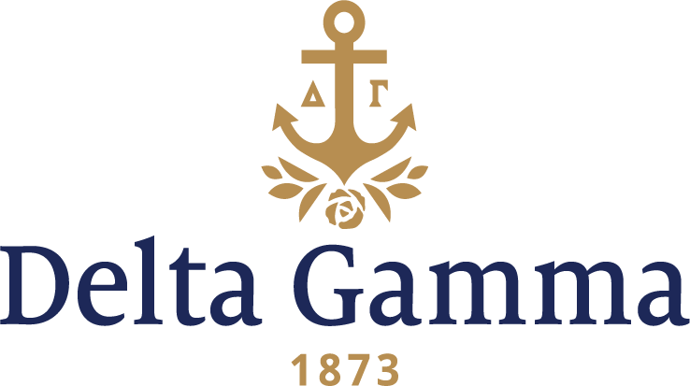

**Beta Tau-Miami (Florida)**

**Fast Facts:**

* Installation date: February 16, 1946
* Location: Coral Gables, FL
* Region: 3

**History:**

A group of citizens chartered the University of Miami (UM) in 1925 with the intent to offer "unique opportunities to develop inter-American studies, to further creative work in the arts and letters, and to conduct teaching and research programs in tropical studies". They believed that a local university would benefit their community. They were overly optimistic about future financial support for UM because the South Florida land boom was at its peak. During the Jim Crow era, there were three large state-funded universities in Florida for white males, white females, and black coeds (UF, FSU, and FAMU, respectively); in this accord, UM was founded as a white, coeducational institution.

The university began in earnest in 1925 when George E. Merrick, the founder of Coral Gables, gave 160 acres and nearly $5 million to the effort. These contributions were land contracts and mortgages on real estate that had been sold in the city. The university was chartered on April 18, 1925 by the Circuit Court for Dade County.

In June of 1944, due to the rapid growth of the University of Miami, the Delta Gamma alumnae in Miami decided to work towards establishing a Delta Gamma chapter. In April 1945, after a lot of correspondence and many meetings, the expansion was approved by UM administrators and Council; Dorothy Wildasin, Fraternity Secretary and Expansion Chairman, felt the time was right to build a collegiate chapter in Miami. After several conferences with the University of Miami administrators and many letters from Mrs. Wildasin, the field of expansion opened at Miami. Province XI chapters affirmed and approved the expansion votes.

Because of Dorothy’s contacts with Mary B. Merritt, Dean of Women, and other university officials, permission was given to create a nucleus of members for the colony. Dean Merritt opened her files to help find names of unorganized upper-class women. After interviewing several candidates, eight outstanding upper class women were selected. Betty Zoe Passmore (a transfer from Arizona and a Delta Gamma pledge at Alpha Phi), Bernice Hamilton, Frances Abernathy, Carita Ross, Kay Sullivan, Betty June Cook, Marion Dodt and Elena Verson (who had just married John Amos but both were completing their work at the university), made up this impressive group of young women. Mary Jeanne Bohannan, field secretary arrived a few days before the fall semester started to help with fall rushing of the colony and to help the group with Delta Gamma traditions. Barbara Walsh, Phi- Colorado, sacrificed credits to transfer to Miami to assist the new chapter.

The university had fully outgrown its growing pains and was ready to take its place among the outstanding universities of America. The enrollment was 3,450 students on the new 245-acre campus site. Dr. Bowman F. Ashe, President of Miami, engineered the development was noted for his strength of character and hospitality. A Sigma Alpha Epsilon fraternity member, himself, he became the vital spark in the expansion. Dean of Women Mary Merritt, a Phi Mu Fraternity National Panhellenic Conference delegate, brought the desire to create a fair and Panhellenic spirit to the expansion, and was equally helpful.

As the university planned a new building program on a future campus for national fraternities, the groups were allotted rooms for their use. Delta Gamma furnished their room in blue, gold and rose and it was thought the most attractive of any sorority room. Alumnae Kathryn Thompson, Dorothy Stevens and Dorothy Sweet selected and arranged the furnishing in the San Sebastian dormitory.

The first real rush experience of the colony was second semester. Six new pledges were added to the roster. Installation came around quickly in February 1946 and all thirteen undergraduates met at an inspiring Fraternity Round Table in the Coral Gables Congregational Church where Council members gave both collegiate and alumnae members a clear conception of the functions of the Council. It was a thrilling experience for the thirteen charter members of Beta Tau.

Initiation of thirteen undergraduates and fourteen honorary members during the afternoon of Saturday, February 16, 1946 followed by the Installation Banquet at the Shoremede Hotel filled a moving day. With the theme of “A Delta Gamma Garden,” the tables were decorated with conch shells and tropical blooms, arranged by toastmistress, Esther Hurst Haines, Theta- Indiana. The charter was presented to chapter president, Martha Kay Sullivan, from Mrs. Bingham, and Dorothy Wildasin distributed certificates of membership to each new Delta Gamma. Perhaps a quote from Oliver Wendell Homes, given as a toast by Betty June Cook, summed up the activities of the day: “But friendship is a breathing rose with sweets in every fold.”

On Sunday, February 17, the Fraternity Council of the university introduced the newest chapter of Delta Gamma at a reception. The dignity of the receiving line was lost for a few minutes when two Sigma Chi’s arrived with a large banner inscribed “Sigma Chi welcomes Delta Gamma.” The collegiate chapter members were awed by this expression and after the weekend was over all felt the efforts put forth in preparing the colony were culminated in a glorious weekend.

The Beta Tau chapter held the first ever Anchor Splash® in 1966, which has grown to be the biggest fundraising event for Delta Gammas all over the world, with all proceeds benefitting the Foundation.

In 1993, the Beta Taus made a pledge towards Touch Tomorrow for the sum of $10,000.